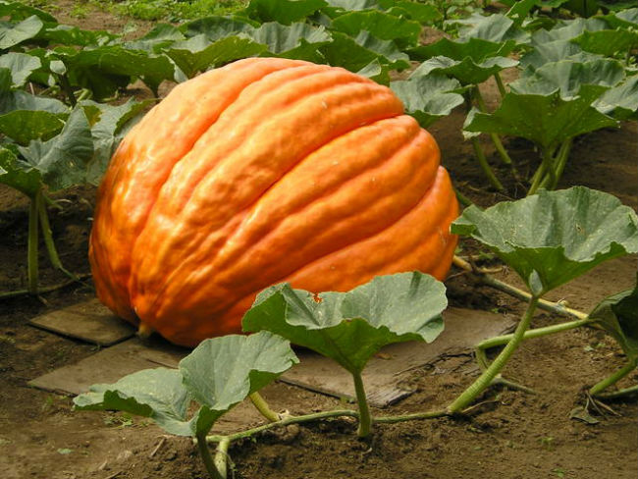  Giant pumpkin contest  PRIZE MONEY  1st $300, 2nd $200, 3rd $100  Prettiest Pumpkin $25  GIANT PUMPKIN WEIGH OFF RULES  1. Judging will take place Saturday, October 12th at noon.  2. Unloading and registration starts on Friday, October 11 from 6pm– 9pm or Saturday, October 12 from 9am – 12pm. No entries allowed after 12pm.  3. No registration fee per competitor.  4. The pumpkin must have been grown and cared for by the exhibitor.  5. Pumpkins must be on pallets. A forklift will be available to unload and load pumpkins.  6. Each pumpkin must be sound, healthy and undamaged. Entries must be free of rot, holes and/or cracks through to the interior cavity, chemical residues and serious soft spots. Cracks, holes and openings shall be free of any foreign material.  7. Chemical residues and soil must be cleaned from the pumpkin surface prior to arrival.  8. Placings and premiums will be awarded based on the final, official weight of all pumpkins. In the event of a tie, the prize money for that placing will be split equally.  9. Roberts Farms will assume no liability for any injury or accident occurring in transit to or from or while on the grounds. Roberts Farms is also not responsible for lost, stolen or damaged goods.  10. The top pumpkin MUST be left until Sunday, October 27 at 6pm for display or prize money will be forfeited. The 2nd and 3rd place pumpkins are to remain on display until Sunday,  October 13 at 6 pm or prize money will be forfeited. All other pumpkins can be taken home at the conclusion of the contest.  11. There will be a secure, roped-off area provided for displaying the pumpkins.  Roberts Farms Fall Fun on the Farm attraction will also be open from 12pm – 9pm. Guests can enjoy a corn maze, hay maze, barrel train rides, inflatables, storybook trail, jump in the corn box, family fall games, u-pick pumpkin patch, u-pick sunflower patch and so much more!  Concessions and restrooms available on site. | 2019  GIANT PUMPKIN CONTEST AT  ROBERTS FARMS  ────  Registration  Friday, Oct. 11 from 6pm – 9pm  Saturday, Oct. 12 from 9am – 12pm  ────  Contest at 12 pm on October 12  ────  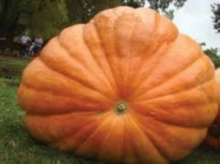  ROBERTS FARMS  2085 W 900 N  Wawaka, IN 46794  574-202-2660  www.haymaze.net

